**sudo curl -LO** [**https://dl.k8s.io/release/$(curl -L -s https://dl.k8s.io/release/stable.txt)/bin/linux/amd64/kubectl**](https://dl.k8s.io/release/$(curl%20-L%20-s%20https:/dl.k8s.io/release/stable.txt)/bin/linux/amd64/kubectl)

install the kops

**curl -LO** [**https://github.com/kubernetes/kops/release/download/v1.25.0/kops-linux-amd64**](https://github.com/kubernetes/kops/release/download/v1.25.0/kops-linux-amd64)

kops-linux-amd64 file to usr/local/bin/kops path by using command

**mv kops-linux-amd64 /usr/local/bin/kops**

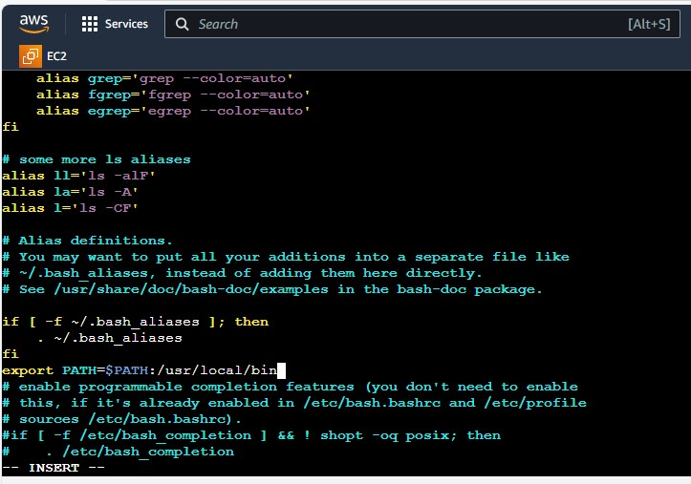

Create the s3 bucket by using below command

**aws s3api create-bucket --bucket bucketname --region us-east-1**

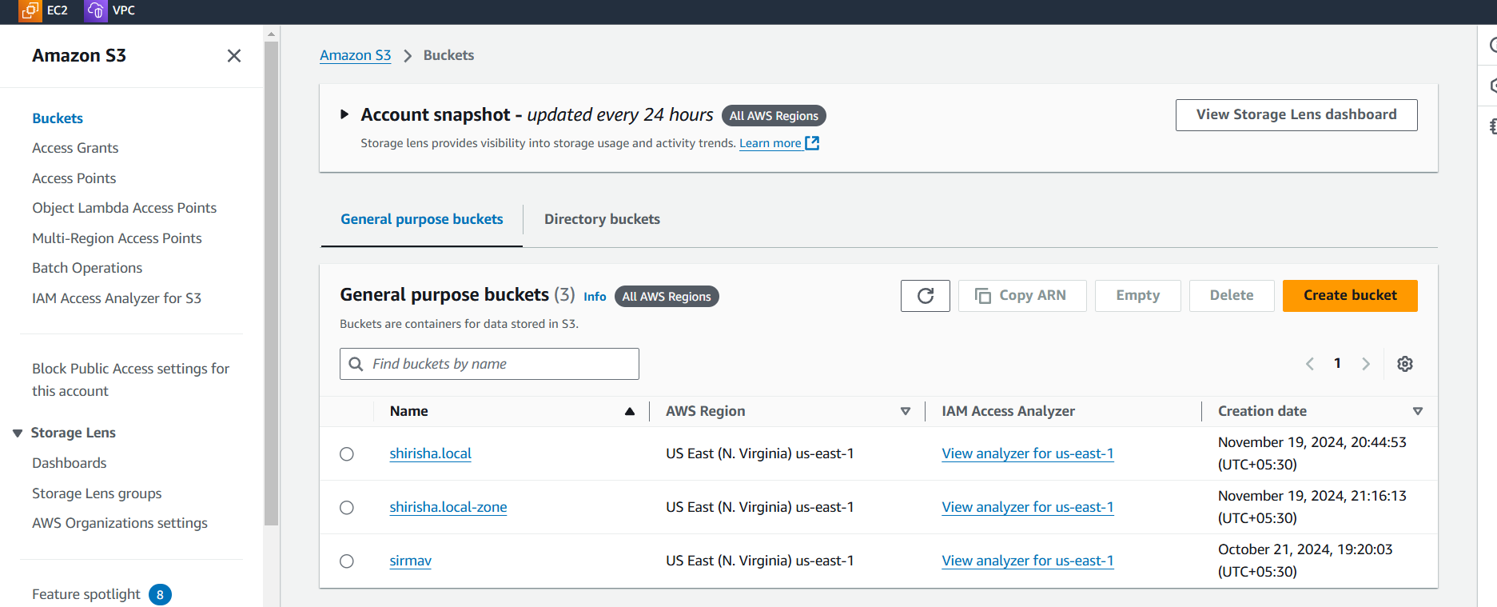

**aws s3api put-bucket-versioning --bucket bucketname --versioning-configuration Status=Enabled**

**export kops_state_store=s3://bucckeet23**

**kops create cluster --name name of the cluster --state=s3://bucketname --zones us-east-1a --master-size t2.medium --node-size t2.micro**

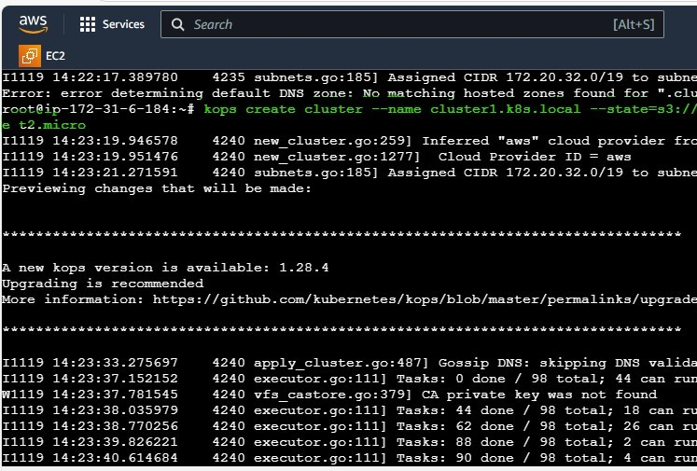

**kops get clusters –state=s3://bucketname**

**kops update cluster --name clustername --yes --admin --state=s3://bucketname**

**Master and worker node is created on AWS**

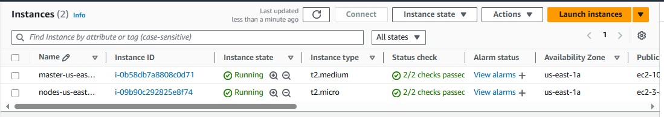

**Create the Autoscaling group**

